Hat Creek Radio Observatory

Technical Details and Rate Sheet

**1 April 2021**

## Overview

The Hat Creek Radio Observatory is a multi-disciplinary facility which is operated by the SETI Institute. The observatory houses a number of instruments and research projects including the 42-element Allen Telescope Array.

## HCRO use

Use of the Hat Creek Radio Observatory is available for shared-risk scientific and research activities. Observing time on the ATA is available on a proposal and cost-recovery basis. Proposals are evaluated based on scientific merit and are accepted from all research and educational institutions as well as individual investigators. Guest experiments, instruments and equipment must comply with observatory policies including those related to electromagnetic interference minimization.

## Services

HCRO offers the following services to research and educational institutions:

* Observations using the Allen Telescope Array
  + As individual antennas, groups of antennas or the entire array
  + Using the ATA’s general purpose DSP backend
  + Using USRP and other SDR peripherals
  + Using user-supplied equipment
* ATA general DSP backend modes
  + Raw digitized signals available via 100Gbit ethernet
  + Arbitrary spectral or temporal resolution full Stokes spectroscopy
  + Wide-bandwidth multi-antenna voltage recording
* Hosting guest instruments on site including colocation in the ATA Signal Processing Room
  + Complete systems
  + Antennas
  + Guest receivers on ATA dish(es)

## commercial rate fee

|  |  |
| --- | --- |
| **Activity / Equipment** | **Hourly Rate** |
| **ATA (Single Antenna - without digital instrumentation)** | $100 / hour |
| **ATA (Full Array - includes available instrumentation)** | $600 / hour |
| **Observing and Instrumentation Support (9am - 5pm)** | $200 / hour |
| **Observing and Instrumentation Support (24 hour)** | $400 / hour |
| **Other Hosted Equipment (as available, up to 10 m2)** | $200 / month + utilities |

## 

|  |  |
| --- | --- |
| **Colocation** | **Rate** |
| **1U space allocation (1 Amp / 10 Mbps / Gateway)** | $125 / month |
| **Static IP Address (as available)** | $25 / month |
| **Network and Server Support (9am - 5pm / Mon-Fri)** | $125 / hour |
| **Network and Server Support (24 hour)** | $250 / hour |

## 

|  |  |
| --- | --- |
| **Accommodations** | **Rate** |
| **Dormitory Housing (based on double occupancy)** | $40 / night cleaning fee |
| **Residential-style housing (3 br / 2 ba)** | $800 / month + utilities |
| **Trailers / Campers** | Contact |

## 

|  |  |
| --- | --- |
| **Utilities** | **Rate** |
| **Power (line)** | $0.25 per kw-hr |
| **Power (conditioned / UPS)** | $0.50 per kw-hr |
| **Waste Disposal and Other Utilities** | Contact |

**Alternative arrangements for non-profit educational and/or research use are available. Please contact us for more information.**

## Location

|  |  |
| --- | --- |
| **Name** | Hat Creek Radio Observatory |
| **Address** | 42231 Bidwell RD, Hat Creek, CA 96040 |
| **Altitude** | 1008 m |
| **Latitude** | 40° 49' 03" N |
| **Longitude** | 121° 28' 24" W |

## Antennas

|  |  |
| --- | --- |
| **Architecture** | 42 dishes – 6.1 m offset Gregorian |
| **Currently available for observations** | 16 as of 1 April 2021 |
| **Array maximum baseline** | 300 m |
| **Elevation range** | 16 to 87 deg |
| **Max elevation speed** | 1 deg/sec |
| **Azimuth range** | -90 to 450 deg |
| **Max azimuth speed** | 3 deg/sec |
| **Operating frequency** | 1 – 11.2 GHz |
| **Feed design** | Log-periodic |
| **Polarization** | Dual linear |
| **Feed operating temperature** | 80 Kelvin |
| **System temperature ()** | 45 Kelvin @ 2 GHz; 60 Kelvin @ 8 GHz |
| **HPBW** | 3.5° @ 1 GHz; 0.58° @ 6 GHz; 20.9′ @ 10 GHz; |

## Time standard

|  |  |
| --- | --- |
| **Time sync** | GPS (Meridian II) |
| **Station clock** | Ultra-Stable OCXO |
| **Available reference signals** | 10MHz; 1PPS |

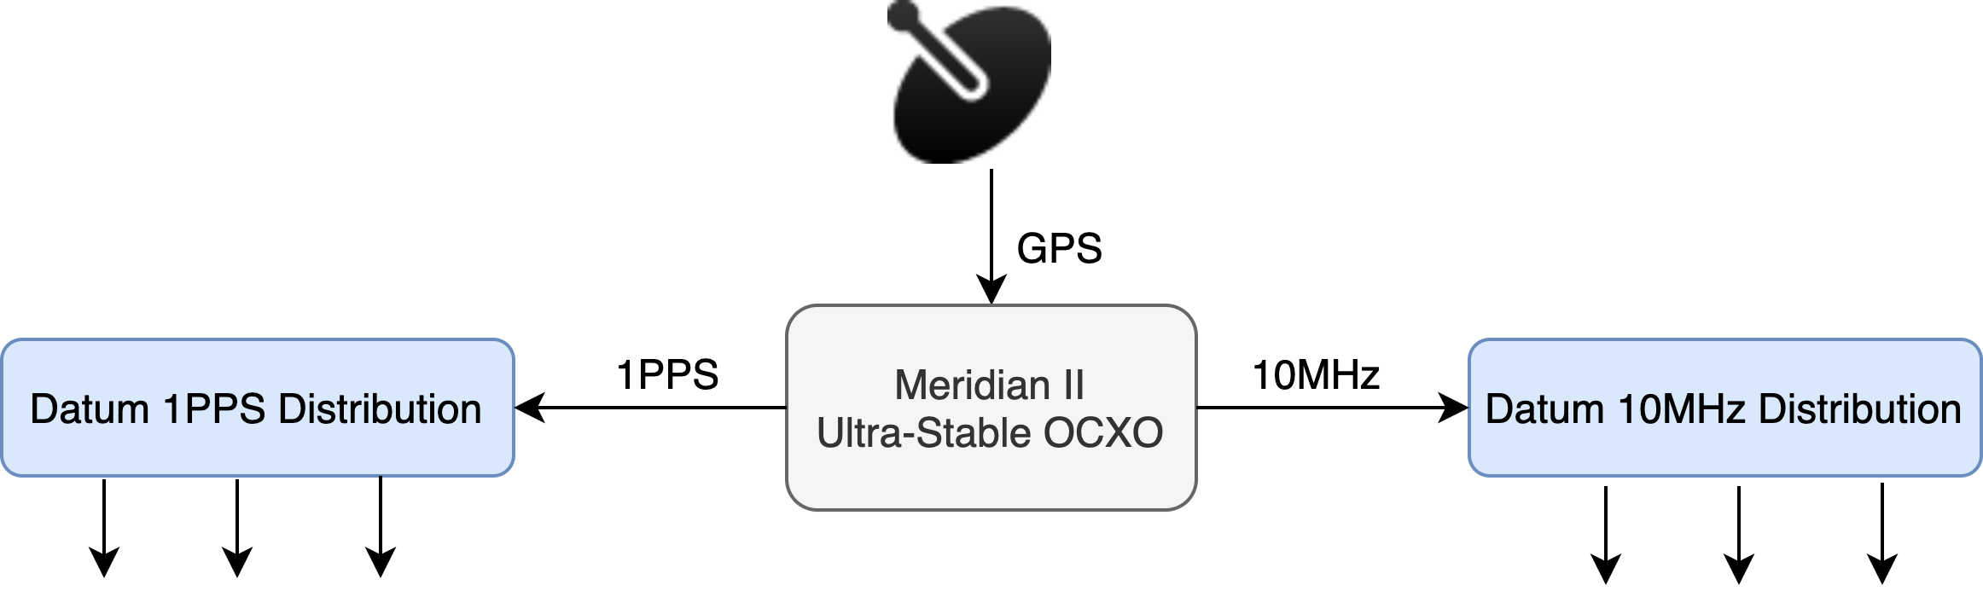

## Radio Frequency (RF)

|  |  |
| --- | --- |
| **Cryogenic low noise amplifier** | LNF-ABLNC1_15A; 35dB gain; 1 – 15 GHz |
| **Post amplifier module (PAM)** | 60dB gain; 0 - 63 dB variable attenuator; 0.5 dB step |
| **PAM 1 dB gain compression** | +8 dBm |
| **Analog fiberoptic link converter** | Photonic Systems; PSI 1601 |
| **Fiber link noise figure** | ≤ 45 dB |
| **Fiberoptic 1 dB gain compression** | +11 dBm |
| **Fiberoptic connectors** | FC/APC |
| **Optical wavelength** | 1550 nm |

## intermediate FREQUENCY (IF)

|  |  |
| --- | --- |
| **Number of independent IF bands** | 4 |
| **IF bandwidth** | 700 MHz |
| **Number of tunable LO** | 4 |
| **Number of fixed LO** | 1 |
| **Frequency range of tunable LO** | 16 – 26.7 GHz |
| **Frequency of fixed LO** | 16.012 GHz |
| **AAF center frequency** | 512 MHz |
| **IF output power range** | -10 dBm to -30 dBm |
| **IF output connector** | SMA |

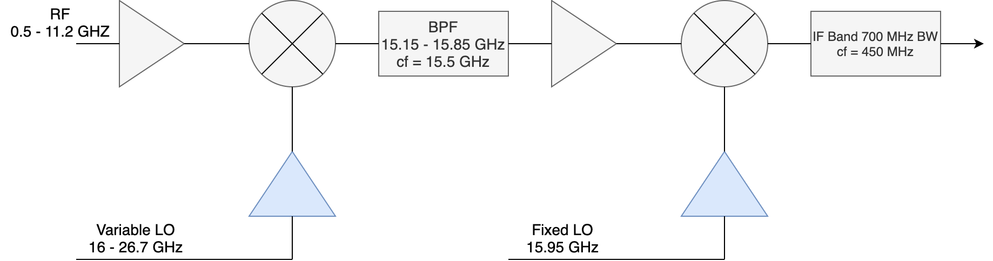

## Control interface

|  |  |
| --- | --- |
| **Telescope control software** | Python 3.5 based library; ATATools.ata_control |
| **GitHub location** | <https://github.com/SETIatHCRO/ATA-Utils> |
| **Software version** | 1.0.3 |
| **Requirements** | 'ephem'; 'astropy'; 'numpy'; 'tftpy'; 'pyuvdata' |

## Network

|  |  |
| --- | --- |
| **Internet connection** | 1 Gbps full duplex |
| **Site access** | VPN; SSH |
| **Available public IPs** | 254 |

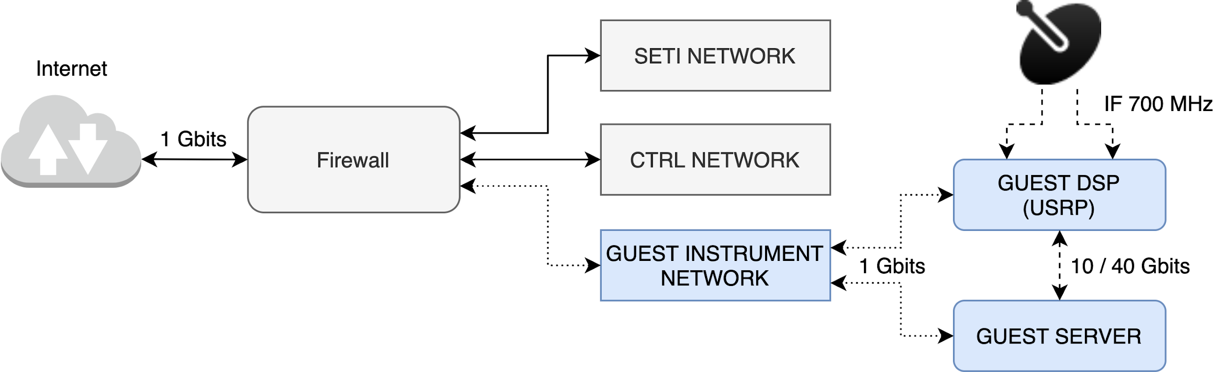

## Processing Backends

|  |  |
| --- | --- |
| **USRP mode** | **Value** |
| **Number of antennas** | 2 |
| **Number of polarization per antenna** | 2 |
| **Sampling rate** | Variable |
| **Usable bandwidth** | Variable |
| **USRP model (2 currently available)** | N320 and N321 |
| **Output rate** | Variable |

|  |  |
| --- | --- |
| **Voltage record mode** | **Value** |
| **Number of antennas** | 20 |
| **Number of polarizations per antenna** | 2 |
| **Number of simultaneous tunings** | 2 |
| **Sampling rate** | 2048 MSPS |
| **Usable bandwidth** | 672 MHz |
| **Polyphase filterbank (PFB)** | Yes |
| **PFB channel width** | 0.5 MHz |
| **Output format** | RAW |
| **Output bitwidth** | 8+8 bit complex unsigned-int |
| **Output throughput (total usable, per tuning)** | 54 GB/s |

|  |  |
| --- | --- |
| **Correlator mode** | **Value** |
| **Number of antennas** | 20 |
| **Number of polarizations per antenna** | 2 |
| **Number of simultaneous tunings** | 2 |
| **Sampling rate** | 2048 MSPS |
| **Usable bandwidth** | 672 MHz |
| **Polyphase filterbank (PFB)** | Yes |
| **PFB channel width** | 0.5 MHz |
| **Correlator integration length** | 1 – 20 seconds |
| **Correlator output format** | UVH5 |
| **Spectral line (high frequency resolution) mode** | Not currently supported |
| **Output throughput (total usable, per tuning)** | Variable |

|  |  |
| --- | --- |
| **Beamformer mode** | **Value** |
| **Number of antennas** | 20 |
| **Number of polarizations per antenna** | 2 |
| **Number of simultaneous tunings** | 2 |
| **Sampling rate** | 2048 MSPS |
| **Usable bandwidth** | 672 MHz |
| **Number of simultaneous tunings** | 2 |
| **Polyphase filterbank (PFB)** | yes |
| **PFB channel width** | 0.5 MHz |
| **Number of beams currently supported** | 1 (boresight) |
| **Requires calibration\*** | yes |
| **Output bitwidth** | 16+16 bit complex half precision float |
| **Output throughput (total usable, per tuning, per beam)** | 5.4 GB/s |

*For a maximum beamformer efficiency, it is advised that the beamformer be calibrated once every 4 hours when observing at frequencies above 5GHz. Phase and delay solutions, empirically, seem to stay stable for 10 hours at low frequencies.

**Contact information:**

## 

|  |  |  |  |
| --- | --- | --- | --- |
| **Alexander Pollak** | Science & Engineering  Operations Manager, HCRO | apollak@seti.org | +1 (530) 335 3264 |
| **Yvonne Nicholas** | Contracts and Procurement Manager | ynicholas@seti.org | +1 (650) 759 1403 |